# Unit 7 Electronic Payment Systems

Electronic payment systems are becoming central to on-line business process innovation as companies look for ways to serve customers faster and at lower cost. Emerging innovations in the payment for goods and services in electronic commerce promise to offer a wide range of new business opportunities.

Electronic payment systems and e-commerce are intricately linked given that on-line consumers must pay for products and services. Clearly, payment is an integral part of the mercantile process and prompt payment (or account settlement) is crucial. If the claims and debits of the various participants—individuals, companies, banks, and nonbanks—are not balanced because of payment delay or, even worse default, then the entire business chain is disrupted. Hence an important aspect of e-commerce is prompt and secure payment, clearing, and settlement of credit or debit claims.

But on-line sellers face a problem: How will buyers pay for goods and services? What currency will serve as the medium of exchange in this new marketplace? Everyone agrees that the payment and settlement process is a potential bottleneck in the fast-moving electronic commerce environment if we rely on conventional payment methods such as cash, checks, bank drafts, or bills of exchange. Electronic replicas of these conventional instruments are not well suited for the speed required in e-commerce purchase processing. For instance, payments of small denominations (micropayments) must be made and accepted by vendors in real time for snippets(pieces) of information. Conventional instruments are too slow for micropayments and the high transaction costs involved in processing them add greatly to the overhead. Therefore new methods of payment are needed to meet the emerging demands of e-commerce. These new payment instruments must be secure, have a low processing cost, and be accepted widely as global currency tender.

We will examine these demands by looking at the following issues:

* + What form and characteristics of payment instruments—for example, electronic cash, electronic checks, credit/debit cards—will consumers use?
  + In on-line markets, how can we manage the financial risk associated with various payment instruments—privacy, fraud, mistakes, as well as other risks like bank failures? What security features (authentication, privacy, anonymity) need to be designed to reduce these risks?

To answer these questions, we will draw on examples of various electronic payment systems that have been proposed, prototyped, or actually deployed (implemented).

**Types of Electronic Payment Systems**: Electronic payment systems grow rapidly in banking, retail, health care, on-line markets, and even government—in fact, anywhere money needs to change hands. Organizations are motivated by the need to deliver products and services more cost effectively and to provide a higher quality of service to customers. Let’s briefly describe the pertinent developments in various industries to provide an overall picture of electronic payment systems of the present.

Research into electronic payment systems for consumers can be traced back to the 1940s, and the first applications—credit cards—appeared soon after. In the early 1970s, the emerging electronic payment technology was labeled electronic funds transfer (EFT). EFT is defined as "any transfer of funds initiated through an electronic terminal, telephonic instrument, or computer or magnetic tape. EFT utilizes computer and telecommunication components both to supply and to transfer money or financial assets.

Work on EFT can be segmented into three broad categories:

## Banking and financial payments

* + Large-scale or wholesale payments (e.g., bank-to-bank transfer)
  + Small-scale or retail payments (e.g., automated teller machines and cash dispensers)
  + Home banking (e.g., bill payment)

## Retailing payments

* + Credit cards (e.g., VISA or MasterCard)
  + Private label credit/debit cards (e.g., J.C. Penney Card)
  + Charge cards (e.g., American Express)

## On-line electronic commerce payments

* + Token-based payment systems

Electronic cash (e.g., DigiCash) Electronic checks (e.g.; NetCheque)

Smart cards or debit cards (e.g., Mondex Electronic Currency Card)

* + Credit card-based payment systems

Encrypted credit cards (e.g., World Wide Web form-based encryption) Third- party authorization numbers (e.g., First Virtual)

Retail payments and large-scale payments between banks and business are widely recognized as the pioneering efforts in electronic commerce that involve the extensive use of EDI for transferring payment information.

**Risks Associated with Electronic Payment System**: Electronic payment is a popular method of making payments globally. It involves sending money from bank to bank instantly

-- regardless of the distance involved. Such payment systems use Internet technology, where information is relayed through networked computers from one bank to another. Electronic payment systems are popular because of their convenience. However, they also may pose serious risks to consumers and financial institutions.

### Tax Evasion

Businesses are required by law to provide records of their financial transactions to the government so that their tax compliance can be verified. Electronic payment however can frustrate the efforts of tax collection. Unless a business discloses the various electronic payments it has made or received over the tax period, the government may not know the truth, which could cause tax evasion.

### Fraud

Electronic payment systems are prone to fraud. The payment is done usually after keying in a password and sometimes answering security questions. There is no way of verifying the true identity of the maker of the transaction. As long as the password and security questions are correct, the system assumes you are the right person. If this information falls into the possession of fraudsters, then they can defraud you of your money.

### Impulse Buying

Electronic payment systems encourage impulse buying, especially online. You are likely to make a decision to purchase an item you find on sale online, even though you had not planned to buy it, just because it will cost you just a click to buy it through your credit card. Impulse buying leads to disorganized budgets and is one of the disadvantages of electronic payment systems.

### Payment Conflict

Payment conflicts often arise because the payments are not done manually but by an automated system that can cause errors. This is especially common when payment is done on a regular basis to many recipients. If you do not check your pay slip at the end of every pay period, for instance, then you might end up with a conflict due to these technical glitches, or anomalies.

**5.1 Digital token and E- payment systems,**

None of the banking or retailing payment methods is completely adequate in their present form for the consumer-oriented e-commerce environment. Their deficiency is their assumption that the parties will at some time be in each other's physical presence or that there will be a sufficient delay in the payment process for frauds, overdrafts, and other undesirables to be identified and corrected. These assumptions may not hold for e-commerce and so many of these payment mechanisms are being modified and adapted for the conduct of business over networks.

Entirely new forms of financial instruments are also being developed. One such new financial instrument is "**electronic tokens**" in the form of electronic cash/money or checks. Electronic tokens are designed as electronic analogs of various forms of payment backed by a bank or financial institution. Simply stated, electronic tokens are equivalent to cash that is backed by a bank.

Electronic tokens are of three types:

1. **Cash or real-time**: Transactions are settled with the exchange of electronic currency. An example of on-line currency exchange is *electronic cash* (*e-cash*).
2. **Debit or prepaid**: Users pay in advance for the privilege of getting information. Examples of prepaid payment mechanisms are stored in smart cards and electronic purses that store electronic money.
3. **Credit or postpaid**: The server authenticates the customers and verifies with the bank that funds are adequate before purchase. Examples of postpaid mechanisms are *credit/debit* cards and *electronic checks*.

**5.2 E-cash,**

Electronic cash (e-cash) is a new concept in on-line payment systems because it combines computerized convenience with security and privacy that improve on paper cash. Its versatility opens up a host of new markets and applications. E-cash presents some interesting characteristics that should make it an attractive alternative for payment over the Internet.

E-cash focuses on replacing cash as the principal payment vehicle in consumer-oriented

electronic payments. Although it may be surprising to some, cash is still the most prevalent consumer payment instrument even after thirty years of continuous developments in electronic payment systems. Cash remains the dominant form of payment for three reasons:

1. Lack of trust in the banking system,
2. Inefficient clearing and settlement of noncash transactions, and
3. Negative real interest rates paid on bank deposits.

Now compare cash to credit and debit cards. First, they can't be given away because, technically, they are identification cards owned by the issuer and restricted to one user. Credit and debit cards are not legal tender, given that merchants have the right to refuse to accept them. Nor are credit and debit cards bearer instruments; their usage requires an account relationship and authorization system. Similarly, checks require either personal knowledge of the payer or a check guarantee system. Hence, to really create a novel electronic payment method, we need to do more than recreate the convenience that is offered by credit and debit cards. We need to develop e-cash that has some of the properties of cash.

**What is electronic cash?** : Electronic cash is one of the instruments that can be used to conduct paperless transactions. Paperless transaction is a term used to describe financial exchanges that do not involve the physical exchange of currency. Instead, monetary value is electronically credited and debited. Often called e-cash or [digital money](http://www.wisegeek.com/what-is-digital-money.htm), this financial instrument is commonly used to conduct distant transactions, such as those between parties on the Internet and those between parties in different countries.

In most cases, e-cash is equivalent to paper currency and can therefore be exchanged among individuals or spent for any types of goods or services that a person wishes to acquire. This financial instrument has played a large role in the increasing popularity of telecommuting, which is an arrangement that allows people to work together in distant places.

Digital currency can allow a freelancer in Nepal to be paid for work that the he did for a contractor in Canada. This is possible due to a monetary exchange system. The value of that money is then credited to someone else in another place. The paper currency the sender presents or which is taken from his account is not physically sent and given to the receiver. Electronic cash is exchanged in a similar way. One major difference, however, is that transactions can often be conducted without a live middle man.

People involved in electronic cash transfers may never acquire any paper currency. They may receive their funds electronically and they may use them electronically. This does not mean, however, that it is impossible to get paper currency from electronic cash.

In many instances, electronic money can be converted into paper currency quite easily. This is possible because e-cash is commonly held in an account that can be accessed in several ways. For example, many have debit cards that can be used at an [automated teller](http://www.wisegeek.com/what-is-an-automated-teller-machine.htm) [machine](http://www.wisegeek.com/what-is-an-automated-teller-machine.htm) (ATM). Sometimes, a person can request that all or a portion of the money held electronically be made available by check.

There are a number of advantages of electronic cash. One of them is that it eliminates the apprehension that many people feel about carrying and exchanging paper currency.

Another advantage of electronic cash is that it is usually easily converted to another currency, making traveling and international business substantially easier.

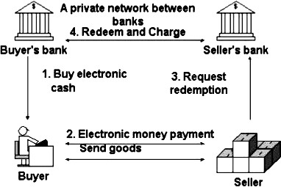

Fig: Transaction of Electronic Cash.

The figure shows the basic operation. User A obtains digital cash "coins" from her bank (and the bank deducts a corresponding amount from her account). The user is now entitled to use the coins by giving them to another user B, which might be a merchant. B receives e-cash during a transaction and see that it has been authorized by a bank. They can then pay the cash into their account at the bank.

Ideal properties of a Digital Cash system should be:

* 1. **Secure**. Alice should be able to pass digital cash to Bob without either of them, or others, able to alter or reproduce the electronic token.
  2. **Anonymous**. Alice should be able to pay Bob without revealing her identity, and without Bob revealing his identity. Moreover, the Bank should not know who Alice paid or who Bob was paid by. Even stronger, they should have the option to remain anonymous concerning the mere existence of a payment on their behalf.
  3. **Portable**. The security and use of the digital cash is not dependent on any physical location. The cash should be able to be stored on disk or USB memory stick, sent by email, SMS, internet chat, or uploaded on web forms. Digital cash should not be restricted to a single, proprietary computer network.
  4. **Off-line capable**. The protocol between the two exchanging parties is executed off-line, meaning that neither is required to be host-connected in order to proceed.
  5. **Wide acceptability**. The digital cash is well-known and accepted in a large commercial zone. With several digital cash providers displaying wide acceptability, Alice should be able to use her preferred unit in more than just a restricted local setting.
  6. **User-friendly**. The digital cash should be simple to use from both the spending perspective and the receiving perspective. Simplicity leads to mass use and mass use leads to wide acceptability. Alice and Bob should not require a degree in cryptography as the protocol machinations should be transparent to the immediate user.

Here is the summary of the pros and cons of the online electronic cash system:

## Pros

* Provides fully anonymous and untraceable digital cash:
* No double spending problems (coins are checked in real time during the transaction).
* No additional secure hardware required

## Cons

* Communications overhead between merchant and the bank.
* Huge database of coin records -- the bank server needs to maintain an ever- growing database for all the used coins’ serial numbers.
* Difficult to scale, need synchronization between bank servers.
* Coins are not reusable

**5.3 E- Cheque,**

When you write a check, you may assume that the piece of paper you write on will be deposited at a bank and processed manually. Electronic check conversion makes that process less and less likely. Instead of processing the piece of paper, some businesses prefer to turn your paper check into an electronic check.

**How Electronic Checks Work?** How does a piece of paper become an electronic check? The business you write the check to slips the check into a machine that reads information from your check. That information is all the business needs to collect money from your bank account.

With E-Checks, a check imager is connected to a small printer through a credit card terminal directly at the point of sale. When a customer presents a check, the check is scanned by the imager, the magnetic data (MICR) indicating the bank routing number and account number are read, and the dollar amount of the check is entered. The E- Check process verifies the check by comparing the check's bank account and the customer’s driver’s license with a national negative database to determine if the account has a fraud history, is closed, or has had insufficient funds (NSF) problems. If the check is approved, a receipt is printed for customer signature. The check and a copy of the signed receipt are returned to the customer. The captured data is used in the electronic transfer of money through the Automated Clearing House (ACH) system.

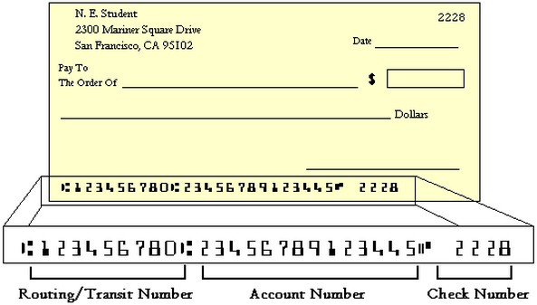

Fig: Electronic Check Format.

Merchant benefits of converting checks to an electronic form:

* Saves you time with your deposits - no more bank runs or long teller lines.
* Lowers traditional bank fees, like per item deposit and returned item fees.
* Funds you quickly, usually within 2 business days of the original transaction.
* Secures your customer’s personal and bank account information by returning the original item to the check writer.
* Provides your customers complete transaction information for easy bank reconciliation, as well as providing sales information, like store name and location.
* 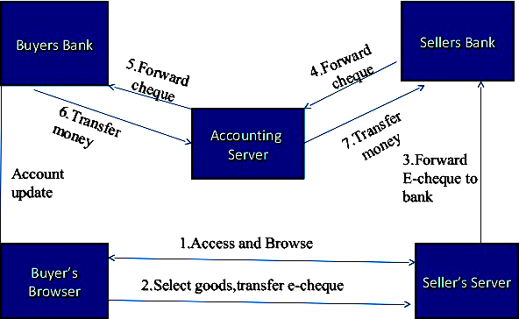Expandable equipment is simple and user friendly.

**Impact of Electronic Checks**: Electronic checks allow businesses to process payments more quickly. As a result, the money will come out of your checking account sooner than you might expect. You need to make sure you have enough money in your account when you write a check, and you can’t rely on ‘float’ time as much as you might have in the past. Keep a balanced checkbook and consider some type of overdraft protection plan. Since you’re paying electronically anyway, you now have even less reason to write checks the old fashioned way.

**Where Electronic Check Conversion Happens?** Your paper checks may be converted to electronic checks right in front of you, or it may happen when you mail a check to somebody to pay a bill. Either way, they’re making an electronic check so that they can process your payment electronically.

**Electronic Check Disclosure and Identification:** Businesses are supposed to notify you that they’re making an electronic check. If you’re in a store, there should be a sign near the register that says they’ll turn your paper check into an electronic check. If you’re mailing in a check to pay a bill, the company probably disclosed their electronic check policy somewhere in the fine print of an agreement or on the back of your statement. If

the cashier drops your check into a machine and hands it back to you when you make a purchase, they’ve used an electronic check.

**5.4 Smart card,**

A smart card is a device that includes an embedded integrated circuit chip (ICC) that can be either a secure microcontroller or equivalent intelligence with internal memory or a memory chip alone. The card connects to a reader with direct physical contact or with a remote contactless radio frequency interface. With an embedded microcontroller, smart cards have the unique ability to store large amounts of data, carry out their own on-card functions (e.g., encryption and mutual authentication) and interact intelligently with a smart card reader. Smart card technology is available in a variety of form factors, including plastic cards, fobs, subscriber identity modules (SIMs) used in GSM mobile phones and etc.

***Smart Card Technology****: There are two general categories of smart cards:* ***contact*** *and*

***contactless*** *as shown in figure below****.***

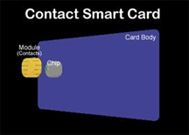 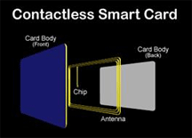

A contact smart card must be inserted into a smart card reader with a direct connection to a conductive contact plate on the surface of the card (typically gold plated). Transmission of commands, data, and card status takes place over these physical contact points.

A contactless card requires only close proximity to a reader. Both the reader and the card have antennae, and the two communicate using radio frequencies (RF) over this contactless link. Most contactless cards also derive power for the internal chip from this electromagnetic signal. The range is typically one-half to three inches for non-battery- powered cards, ideal for applications such as building entry and payment that require a very fast card interface.

Two additional categories of cards are **dual-interface cards** and **hybrid cards**. A hybrid card has two chips, one with a contact interface and one with a contactless interface. The two chips are not interconnected. A dual-interface card has a single chip with both contact and contactless interfaces. With dual-interface cards, it is possible to access the same chip using either a contact or contactless interface with a very high level of security.

The chips used in all of these cards fall into two categories as well: microcontroller chips and memory chips. A memory chip is like a small floppy disk with optional security. Memory chips are less expensive than microcontrollers but with a corresponding decrease in data management security. Cards that use memory chips depend on the

security of the card reader for processing and are ideal for situations that require low or medium security.

A microcontroller chip can add, delete, and otherwise manipulate information in its memory. A microcontroller is like a miniature computer, with an input/output port, operating system, and hard disk. Smart cards with an embedded microcontroller have the unique ability to store large amounts of data, carry out their own on-card functions (e.g., encryption and digital signatures) and interact intelligently with a smart card reader.

The selection of a particular card technology is driven by a variety of issues, including:

* Application dynamics
* Prevailing market infrastructure
* Economics of the business model
* Strategy for shared application cards

Smart cards are used in many applications worldwide, including:

* **Secure identity applications** - employee ID badges, citizen ID documents, electronic passports, driver’s licenses, online authentication devices
* **Healthcare applications** - citizen health ID cards, physician ID cards, portable medical records cards
* **Payment applications** - contact and contactless **credit/debit cards**, transit payment cards
* **Telecommunications applications** - GSM Subscriber Identity Modules, pay telephone payment cards

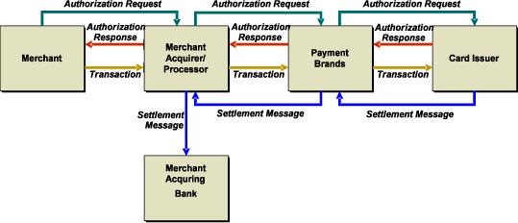

**5.5 Credit Card based payment system**

“A generation ago, it wasn’t all that unusual to be out for dinner with friends or at the register with a cart full of groceries and realize you didn’t have enough cash to cover the bill. But today, you’re likely to pull out a debit or credit card and not think anything of it.”

It’s hard now to imagine a time when those noncash options weren’t available — especially if you were born in the 1970s or later. Credit cards [have been around](http://www.ffiec.gov/ffiecinfobase/resources/retail/frb-guide%20to%20the_atm_debit_card_ind.pdf) since the 1950s, and debit cards were introduced in the mid-1970s. By [2006](http://www.creditcards.com/credit-card-news/credit-card-industry-facts-personal-debt-statistics-1276.php), there were 984

million bank-issued [Visa](http://topics.nytimes.com/top/news/business/companies/visa_inc/index.html?inline=nyt-org) and [MasterCard](http://topics.nytimes.com/top/news/business/companies/mastercard-inc/index.html?inline=nyt-org) credit and debit cards in the United States alone.

Though the two types of cards may be used interchangeably, there are notable differences between them. Let’s start with debit cards.

**Debit Cards:** Debit cards are linked to your bank account so the money you spend is automatically deducted from your account. They provide a convenient alternative to cash, especially if you do a lot of shopping online. Debit cards can also help you budget. Use your card to pay your bills and day-to-day expenses and your monthly statement will provide a good snapshot of how much you spend per month and where it’s going. There’s another benefit as well: Unlike credit cards, your bank balance goes down with each debit card transaction, so you’re less likely to overspend. (Many banks offer “overdraft protection” that allows you to exceed your balance. But you’ll end up paying interest, and maybe extra fees, on the money you borrow from your overdraft account.)

With so many benefits to the debit card, why use a credit card at all? There are three main reasons: You can spend more than you have — or postpone paying, at least — and you typically get better rewards and better protection than you do with debit cards.

**Credit Cards:** Credit cards basically allow you to use someone else’s money (the card issuer’s) to make a purchase while you pay the money back later. If you do so within the billing period — generally, 15 to 45 days — you can avoid paying any interest on it. The problem arises, of course, when you don’t pay the balance in full and are charged interest as well. That can quickly [add up.](http://www.bankrate.com/brm/cgi-bin/apr.asp) If it takes you two years to pay off a $500 balance, for example, and you’re being charged 18 percent interest, you’ll end up paying nearly $100 more in interest.

If you use them responsibly though, credit cards can offer other advantages. They help build your credit, as long as you pay your bills on time. Some also offer rewards that you can use to get gifts, cash back or discounts for products, services and special events. They also provide more protection if someone steals your card or bank information. If you notice a fraudulent charge on your credit card account, you can call the card issuer, make a dispute claim, and the charge should be removed from your balance. But if thieves steal your debit card information and use it, it may take weeks for the bank to investigate your claim and replace the lost funds. In the meantime, you may have to deal with a dwindling bank balance or bounced checks.

Federal law also protects you if you need to dispute charges on a credit card, but not if you use a debit card or other forms of payment. If you paid cash or used a debit card, the retailer already has your money. So you have a lot less leverage, and there’s no guarantee you’ll get that money back. But if you pay for something with your credit card and aren’t happy with the purchase, your card issuer can legally withhold payment from the retailer until they resolve the dispute, and you won’t be charged.

For most people, using both a debit card and credit card makes sense. The key is not to spend more than you have with either. If you can do that, you’ll be able to enjoy the benefits that each provide.

**Working Techniques of Credit Cards**: Credit card payment processing for the e- commerce electronic payment system takes place in two phases: [authorization](http://help.yahoo.com/l/us/yahoo/smallbusiness/store/order/order-11.html#aut) (getting approval for the transaction that is stored with the order) and [settlement](http://help.yahoo.com/l/us/yahoo/smallbusiness/store/order/order-11.html#set) (processing the sale which transfers the funds from the issuing bank to the merchant's account). The flow charts below represent the key steps in the process starting from what a customer sees when placing an order through completing the sale and finishing with the merchant processing the sale to collect funds.

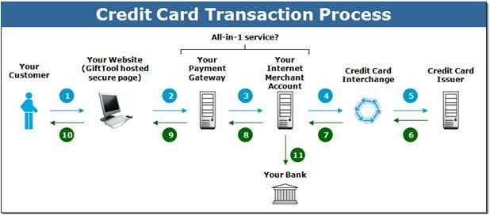

**Benefits and Limitations of Credit Cards**: Advantages and Disadvantages of Credit Cards are:

|  |  |
| --- | --- |
| **Advantages** | **Disadvantages** |
| **Convenience**--Credit cards can save your time and trouble--no searching for an ATM  or keeping cash on-hand. | **Overuse**--Revolving credit makes it easy to spend beyond your means. |
| **Record keeping**--Credit card statements can help you track your expenses. Some cards even provide year-end summaries that  really help out at tax time. | **Paperwork**--You'll need to save your receipts and check them against your statement each month. This is a good way to  ensure that you haven't been overcharged. |
| **Low-cost loans**--You can use revolving credit to save today (e.g., at a one-day sale),  when available cash is a week away. | **High-cost fees**--Your purchase will suddenly become much more expensive if  you carry a balance or miss a payment. |
| **Instant cash**--Cash advances are quick and convenient, putting cash in your hand when you need it. | **Unexpected fees**--Typically, you'll pay between 2 and 4 percent just to get the cash advance; also cash advances usually carry  high interest rates. |
| **Build positive credit**--Controlled use of a credit card can help you establish credit for the first time or rebuild credit if you've had problems in the past--as long as you stay within your means and pay your bills on  time. | **Deepening your debt**--Consumers are using credit more than ever before. If you charge freely, you may quickly find yourself in over your head--as your balance increases, so do your monthly minimum  payments. |
| **Purchase protection**--Most credit card companies will handle disputes for you. If a merchant won't take back a defective product, check with your credit card  company. | **Homework**--It's up to you to make sure you receive proper credit for incorrect or fraudulent charges. |